When you have completed 5-10-15 Trainings, please send your card to the County Office.

Within each 5 trainings, you may use a maximum of 2 on-line sessions.
To obtain your 10 training badge you must have attended at least one Member’s Day.

Essex West County Office
Suite 1
Bates Business Centre
Church Road
Harold Wood
Romford
Essex, RM3 0JF

Tel 01708 373746

E-mail office@girlguidingessexwest.org.uk

When you have completed 5-10-15 Trainings, please send your card to the County Office.

Within each 5 trainings, you may use a maximum of 2 on-line sessions.
To obtain your 10 training badge you must have attended at least one Member’s Day.

Essex West County Office
Suite 1
Bates Business Centre
Church Road
Harold Wood
Romford
Essex, RM3 0JF

Tel 01708 373746

E-mail office@girlguidingessexwest.org.uk

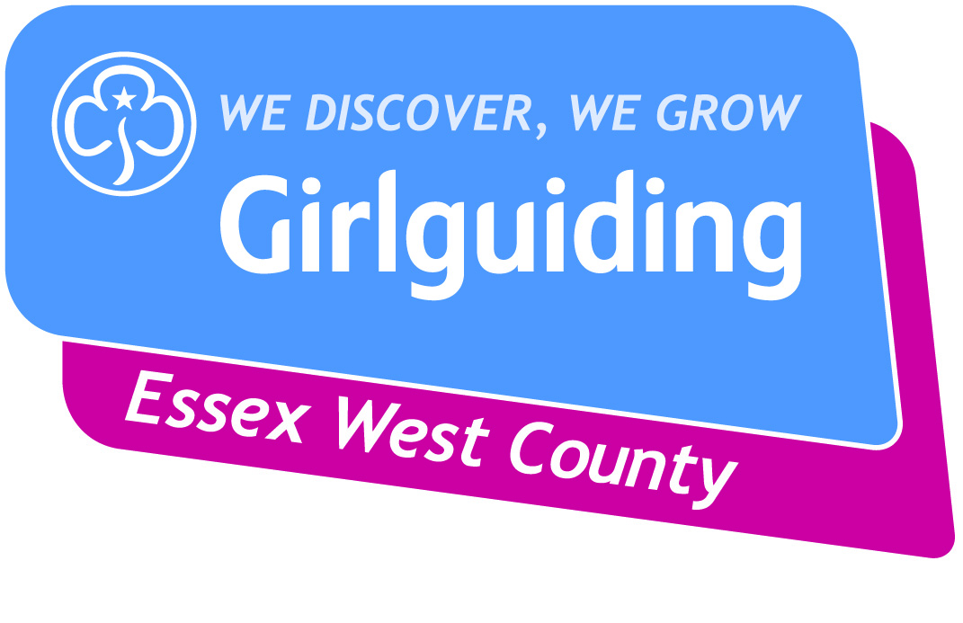

TRAININGS BADGE
Record Card
For All those Aged 16 and over

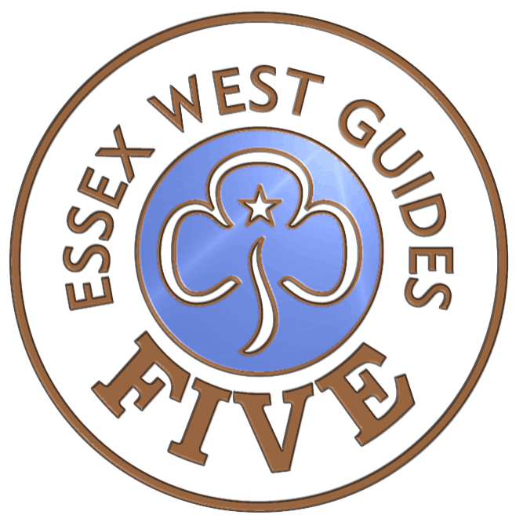

Name: ………………………………………….

Tel: ………………………………………….

Division: ………………………………………….

TRAININGS BADGE
Record Card
For All Those Aged 16 and over

Name: ………………………………………….

Tel: ………………………………………….

Division: ………………………………………

Date | Training & venue | *Type

*Type – e.g. County Day/ Division etc.

Date | Training & venue | *Type

*Type – e.g. County Day/ Division etc.

Date | Training & venue | *Type

*Type – e.g. County Day/ Division etc.

Date | Training & venue | *Type

*Type – e.g. County Day/ Division etc.

