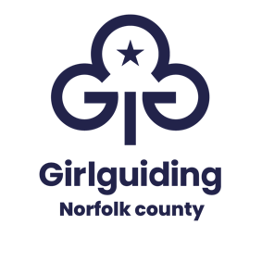
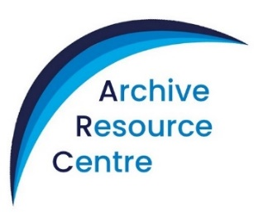
Where guiding history comes alive!

Registered Charity 280532

ARC BADGE ORDER FORM
Please email this form to archivist@girlguidingnorfolk.org.uk

Quantity | Description | Price | Total (£)
 | Postage
 |  | TOTAL £

Print in block letters please
Name
Group
Address
Town |  | Post Code
Tel No (Home) |  | Mobile
Email

PTO
Badges to be collected from the ARC or by prior arrangement with the County Archivist.

Payment
An invoice will be sent confirming methods of payment. Payment may be made by cheque or BACS. A receipt will be emailed on request.

Please make cheques payable to NORFOLK GUIDE ASSOCIATION.

I consent to Girlguiding Norfolk County collecting my details via this form. I understand that the information provided will be processed by Girlguiding Norfolk County in accordance with General Data Protection Requirements, that the data will only be used for processing my purchase and that it will not be shared with other organisations or kept for longer than necessary for this purpose. Full details are included in the Girlguiding Norfolk County Privacy Notice available on request.

Signed: Date:

